Q 2.1
Correct answers marked with an asterisk (*)

1) Do red uniform wearers tend to win more often than those wearing blue uniforms in tae-kwon-do matches where competitors are randomly assigned to wear either a red or blue uniform? In a sample of 80 tae-kwon-do matches, there were 45 matches where the red uniform wearer won.
What is the parameter of interest for this study?
*a. The long-run proportion of tae-kwon-do matches in which the red uniform wearer wins
b. The proportion of matches in which the red uniform wearer wins in a sample of 80 tae-kwon-do matches
c. Whether the red uniform wearer wins a match
d. 0.50

2) Do red uniform wearers tend to win more often than those wearing blue uniforms in tae-kwon-do matches where competitors are randomly assigned to wear either a red or blue uniform? In a sample of 80 tae-kwon-do matches, there were 45 matches where the red uniform wearer won.
What is the statistic for this study?
a. The long-run proportion of tae-kwon-do matches in which the red uniform wearer wins
*b. The proportion of matches in which the red uniform wearer wins in a sample of 80 tae-kwon-do matches
c. Whether the red uniform wearer wins a match
d. 0.50

3) An environmental science teacher at a high school with a large population of students was curious whether the majority (more than half) of students at the school regularly recycle plastic bottles. The teacher selected a random sample of 146 students at the school to interview, then asked each student: "Do you recycle plastic bottles more often than you throw them in the trash?" (Yes/No). Suppose that 89 of the students answered "Yes".
How could coins, a spinner, or cards be used to simulate one of the samples in the simulated null distribution? Select the option that does NOT apply.
a. Flip a coin 146 times, where heads represents "answered Yes." Count the number of heads in 146 flips.
*b. Create a spinner with 61% shaded to represent "answered Yes." Spin the spinner 146 times and count the number of times the spinner lands in the shaded area.
c. Have 5 black cards and 5 red cards where black represents "answered Yes." Draw with replacement from the cards 146 times and count the number of times a black card is drawn.
d. Create a spinner with 50% shaded to represent "answered Yes." Spin the spinner 146 times and count the number of times the spinner lands in the shaded area.

4) A test is being performed to see whether a dog, Hope, understands pointing towards an object. Two objects are placed about 2.5 meters away, then the tester point towards one of the objects. In 20 trials, Hope goes to the correct object 13 times (or 65%).
Finish filling in the blanks with the correct One Proportion applet inputs to carry out an appropriate simulation of this process, if Hope does not understand pointing towards an object and is just guessing.
Probability of success: ___(1)____
Sample size: ___(2)____
Number of samples: Any integer as large or larger than 1000
a. 0.65, 13
b. 0.65, 20
c. 0.5, 13
*d. 0.5, 20

5) Do red uniform wearers tend to win more often than those wearing blue uniforms in tae-kwon-do matches where competitors are randomly assigned to wear either a red or blue uniform? In a sample of 80 tae-kwon-do matches, there were 45 matches where the red uniform wearer won.
Given below is the simulated distribution of the number of "red wins" that could happen by chance alone in a sample of 80 matches. Based on this simulation, is the observed result statistically significant?
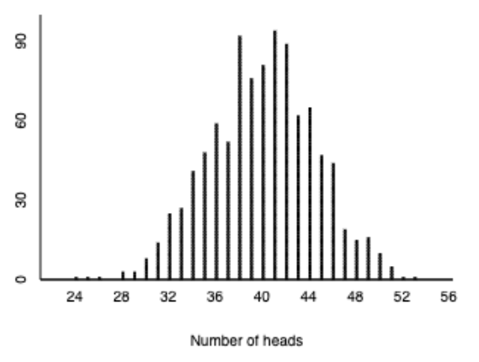
a. Yes, since 45 is larger than 40.
b. Yes, since the height of the dotplot above 45 is smaller than the height of the dotplot above 40.
*c. No, since 45 is a fairly typical outcome if the color of the winner's uniform was determined by chance alone.
d. No, since an observed value greater than 45 could just be by random chance.

6) Which of the following is NOT a step in the 3S Strategy for measuring strength of evidence?
a. Strength of evidence
b. Statistic
*c. Sample
d. Simulate

7) Do red uniform wearers tend to win more often than those wearing blue uniforms in tae-kwon-do matches where competitors are randomly assigned to wear either a red or blue uniform? In a sample of 80 tae-kwon-do matches, there were 45 matches where the red uniform wearer won.
Given below is the simulated distribution of the number of "red wins" that could happen by chance alone in a sample of 80 matches. Based on this simulation, is the observed result statistically significant?
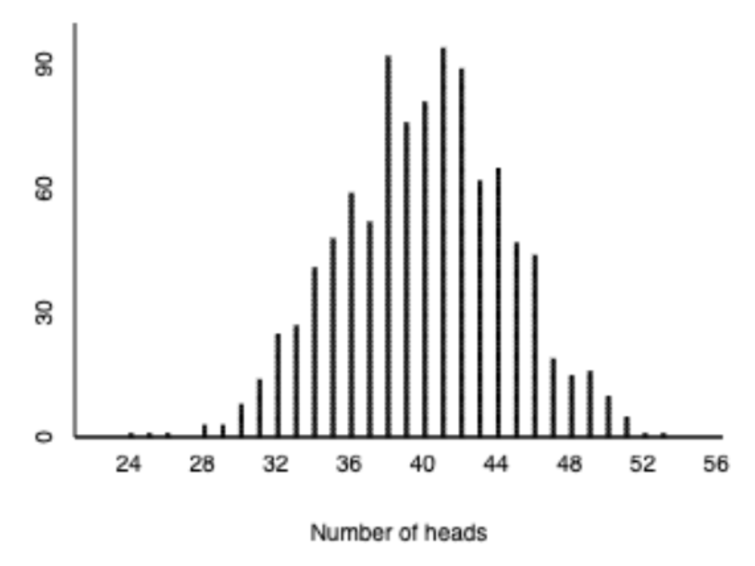
What can be concluded from the results of this study? Select the option that does NOT apply.
a. The results of this study are something that could easily have happened if the color of the winner's uniform was determined by chance alone.
b. Convincing evidence does not exist against the "by-chance-alone" model.
*c. The results of this study prove that the color of the winner's uniform was determined by chance alone.
d. Convincing evidence does not exist that red uniform wearers tend to win more often than those wearing blue uniforms.

